**Instructions on using the script generator “sheet-layout.exe” to setup Autocad layouts for multi sheet drawings:**

* Setup the titleblock in the first layout (eg, fields like client, date; text like Survey control), and name the layout (for most projects this will be 01, but if there are other drawings already setup in the job then set it to the next drawing number.
* Determine the location of all the layouts / sheets in model space. The following procedure is recommended:
  + Ensure the survey data for the project is loaded into the drawing
  + Set the viewport to an appropriate scale, typically 1:100 or 1:200
  + In paperspace: Draw a rectangle to the same extents as the viewport
  + Select the rectangle, then enter “chspace” at the command line to push the rectangle to modelspace.  
    ** If asked about selecting viewport press enter to select the current viewport
  + Switch to the model tab and move / copy the rectangle to plan the sheet positions
* Draw a polyline connecting the bottom left corners of each of the viewports, in the order that the sheets should be numbered  
  
* Extract the coordinates of the polyline vertices to a csv file.   
  There are multiple methods that can be used. A simple method is:
  + select the polyline then run the LIST command (or ‘li’).
  + In the command line window that appears, select the rows of coordinate data
  + Paste the data into a new excel file
  + Use “text to columns”, fixed width,   
    breaklines isolating the coordinate information: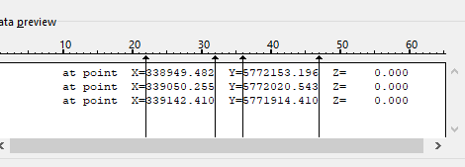  
    skip the non-essential columns  
    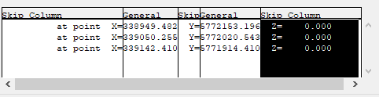  
    finish to get easting/northing or x/y values as 2 columns:  
    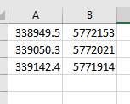
  + Save as csv file with appropriate name into job folder
* Run the sheet-layout.exe application.  
  When prompted:
  + Locate and select the csv coordinate file.
  + Specify the grid spacing. Typically for 1:100 use 10m grid, 1:200 use 20m
  + Specify the first drawing number. Typically this will be 1 (for sheet 01), but can be another number if there are other drawings already setup in the job.
* Once the script has run it will create an Autocad script file (.scr) in the same location and name as the .csv file
* Before running the script file, in CAD check that:
  + “VPGRID v02.lsp” lisp file has been loaded (“manage” menu -> “load application” -> find the file under Civil 3D templates -> “Load”)
  + Remove “_GRID_TEXT” layers (including any numbered layers eg “_GRID_TEXT 01”)
  + The viewport in paperspace is on/visible/ not frozen, and on top of other titleblock entities
* Drag and drop the .scr file into the Autocad drawing area.
* Wait while the script runs, and once complete the sheets will be setup, grids made and frozen in all viewports except thawed in the relevant sheet viewport.